Volunteer
  - at _______________________________________________
Develop new skills  Expand your horizons  Connect with your community  Renew a sense of purpose  Meet new people with life experience  Make intergenerational relationships  Have fun  Make the world a better place | 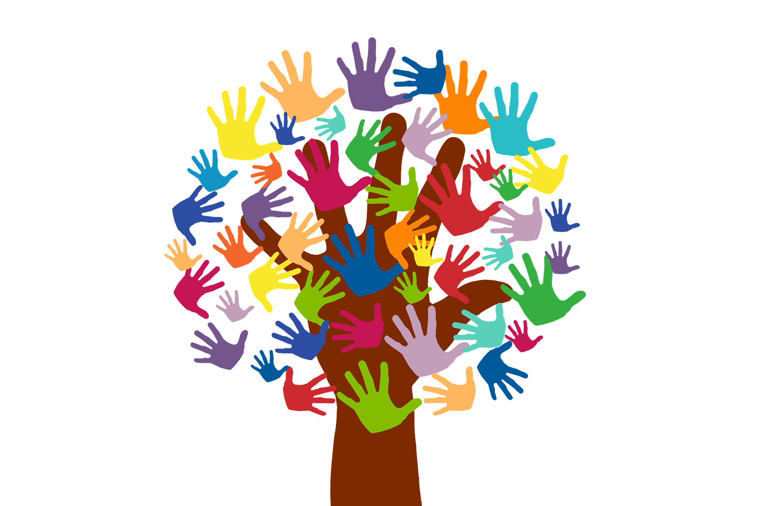

We have multiple opportunities for volunteers! Give a lot of time, or just a little.

Volunteer for a group activity, or be a special friend to someone who needs you.

We LOVE our volunteers!

For more information about volunteering with us, contact _________________________ at _________________________.

